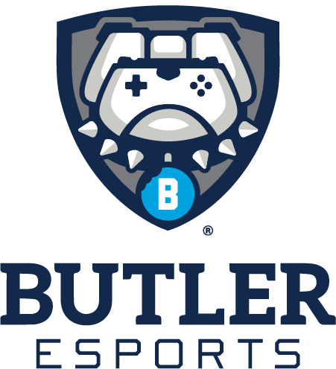

**For Immediate Release**

**Oct. 31, 2022**

**Populous Unveils Multi-Flex Esports Training and Community Hub**

**at Butler University**

*Versatile, Tech-First Space to Host Varsity Esports Teams and Community Events*

**INDIANAPOLIS, IN (October 31, 2022)** – Global design firm Populous has unveiled the multi-use, tech-forward Butler Esports Park, a state-of-the-art esports and innovation space, at Butler University in Indianapolis, Indiana. Opening at the beginning of the 2022-23 academic year, the approximately 7,500-square-foot center will serve as home for Butler’s varsity and club-level esports teams, as well as a communal gathering spot for students and the local community.

Populous, a world leader in esports design, designed the space for maximum flexibility, with its primary function as the home for Butler’s leading esports program, team training, and broadcast production. In addition, it can be easily configured to host a wide spectrum of academic programming, special events, lectures, and student gatherings.

“There was a lot of attention to detail in the design in order to gain maximum operational functionality of the space,” said Eric Kammeyer, Butler University’s director of esports and gaming technology. “Through our partnership with Populous, we have created an innovative and versatile space that will serve our esports teams as well as students and the community, creating more opportunities for them to excel.”

“The Butler Esports Park will serve as a swiss-army knife for the university and the esports program,” said Populous Senior Principal and Esports Director Brian Mirakian. “Its ability to specifically support high-performance skill development for collegiate esports and gaming, combined with robust content creation and broadcast production capabilities, and its infinite uses for events, academic purposes and community engagement, make it a valuable resource.”

The Butler Esports Park was designed to provide students and the local community access to the highest level of resources, technology and amenities. Upon entry, visitors are greeted by retail and informational displays, immersing them in the Butler Esports brand and providing content that showcases daily and upcoming events at the Park. The space opens into a co-working and lounge area with a mix of social seating, collaborative technology and gaming areas. It also features a café to serve students and the community on a daily basis and is a valuable amenity for special event usage.

The gaming arena floor provides a dynamic competitor and spectator environment, accommodating up to 60 gaming stations for everyday student use, varsity team training and premier collegiate competitions. The gaming stations feature an innovative ‘transformer’ design that can easily configure for various modes, and are situated in front of a stage that allows for multiple competition types, academic uses and industry events.

A high-end broadcast and production space supports gaming and content creation, but also is a critical resource for academic development and experiential learning. The Esports Park prominently situates leasable tenant space for leading esports industry organizations Beastcoast and Challonge, houses university office space, and flexible conference space for academic teaching and seminars. Positioned on the northeast side of campus, a new outdoor area serves to extend the social and event functions of the space, and connects the new structure to the rest of the campus.

Populous is a global leader at the forefront of the fast-growing esports and gaming industry. It has created esports venues such as Esports Stadium Arlington, Nerd Street Gamers’ “The Block”, G4tv’s Headquarters in Los Angeles, and the NBA 2K League’s Season 5 Competition and Broadcast Arena in Indianapolis.

**About Butler University**

Butler University is a nationally recognized comprehensive university encompassing six colleges: Arts, Business, Communication, Education, Liberal Arts & Sciences, and Pharmacy & Health Sciences. Approximately 4,500 undergraduate and 1,000 graduate students are enrolled at Butler, representing 46 states and 24 countries. More than 75 percent of Butler students will participate in some form of internship, and Butler students have had significant success after graduation, as demonstrated by the University’s 99 percent placement rate within six months of graduation. The University was recently listed as the No. 1 regional university in the Midwest, according to the *U.S. News & World Report* Best Colleges Rankings, in addition to being included in *The Princeton Review’s* annual “best colleges” guidebook.

**About Populous**

Populous is a global architectural design firm that creates the spaces where people love to be together, like Yankee Stadium, Tottenham Hotspur Stadium, the Super Bowl, and Climate Pledge Arena. Our more than 3,000 projects live at the intersection of sports, entertainment, arts, and culture to amplify emotional connection and belonging. Since 1983, the firm has been connecting people and place through services such as architecture, interior design, event planning, brand activation, wayfinding, urban planning, aviation design and sustainable design consulting. Populous has offices on four continents and regional centers in Kansas City, London, and Brisbane. Learn more at www.populous.com.

**Media Contacts**

Lindsay Church/Sara Williams, Great Ink Communications – [Populous@greatink.com](mailto:Populous@greatink.com); 212-741-2977

Claire Kramer, Populous – [Claire.Kramer@populous.com](mailto:Claire.Kramer@populous.com); 816-329-4211

Mark Apple, Butler University – [MApple1@butler.edu](mailto:MApple1@butler.edu); 317-519-8592