July 19, 2022

The architect trying to revive New York’s tired office skyscrapers

Developers want to spruce up ageing buildings as employers attempt to get workers back to office

By Joshua Chaffin
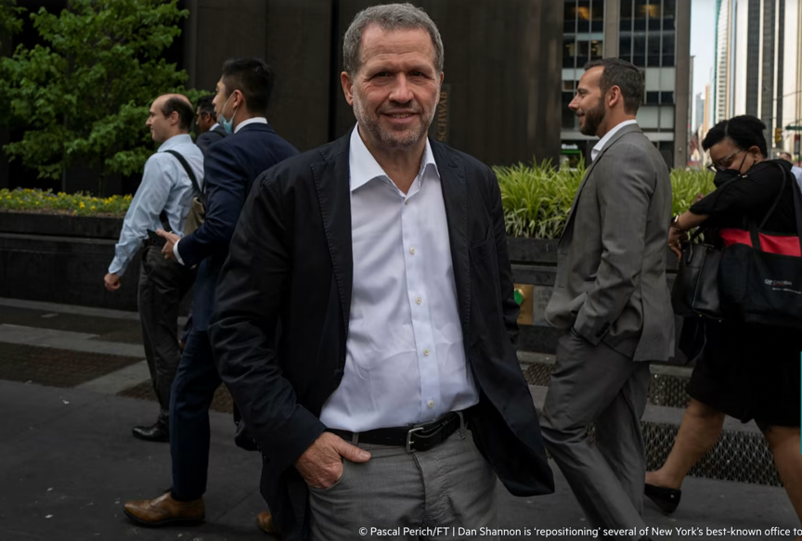
Dan Shannon will happily design a new Manhattan office tower if a client so desires. But more often than not, Shannon, managing partner at New York City architecture firm MdeAS, is asked to breathe new life into old buildings.
© Pascal Perich/FT | Dan Shannon is ‘repositioning’ several of New York’s best-known office towers

He has gained a reputation as one of the city’s foremost practitioners of what architects and developers refer to as “repositioning.”

Demand for that particular trade is being driven by the upheaval in the world’s largest office market wrought by the Covid-19 pandemic and the subsequent rise of working from home. While the newest and flashiest office buildings are still attracting top tenants, middling towers are under mounting pressure to upgrade or risk becoming obsolete.

“It’s pedal to the metal,” Shannon said of his workload. “For every new building we do 10 or 15 conversions. And that’s the same across the city.”

Among other projects, Shannon is working on a near-total gutting of the former One and Two Penn Plaza, drab, 1970s-era towers that loom over Pennsylvania Station, for Vornado Realty Trust; an update of the so-called Lipstick Building at 885 Third Avenue for SL Green Realty; and the McGraw Hill Building on 42nd Street for Resolution Real Estate Partners.

Most recently, Shannon was tapped by Harbor Group International to revive the Black Rock building on Sixth Avenue, a 1960s modernist landmark that was for decades the home of William Paley’s CBS broadcast network.

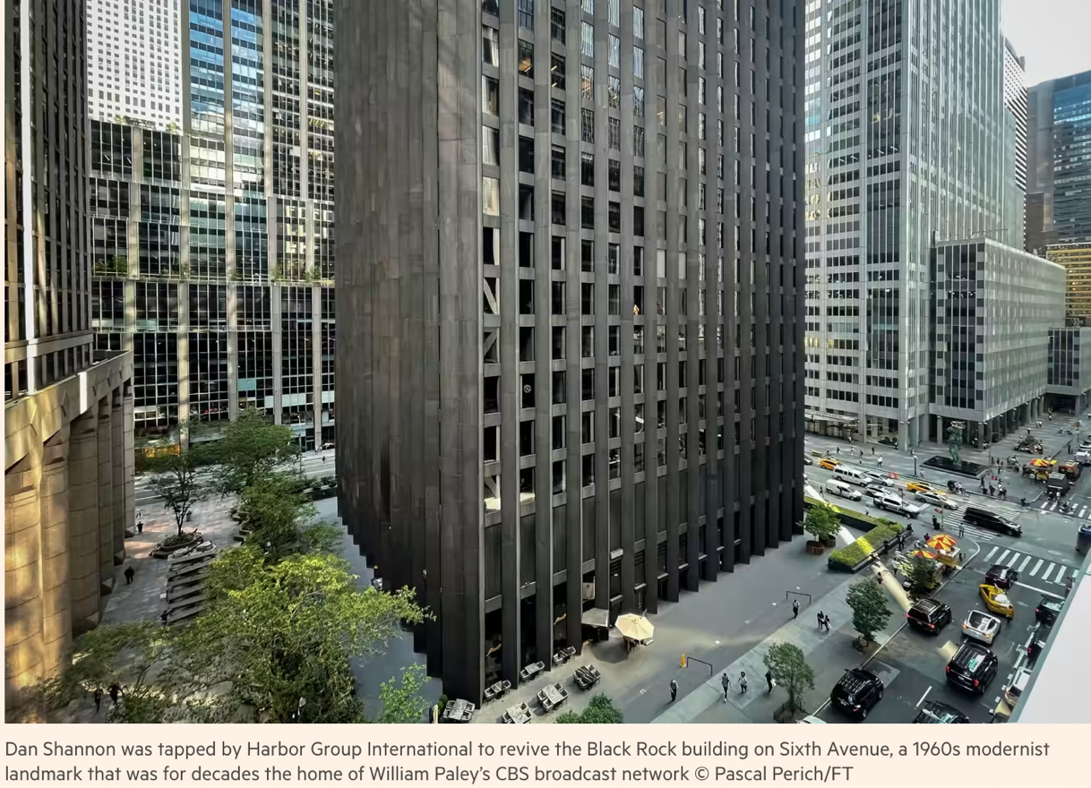

“How do we repolish the Black Rock, and then infuse it with what today’s tenants are looking for?” asked Shannon. About 70 per cent of New York’s 440mn square feet of office space dates from before 1980, so it is ripe to be either demolished or upgraded. If developers were dragging their feet about renovations, Covid appears to be forcing their hands.

Even though uncertainty reigns among New York developers, a consensus is forming that offices must become more vibrant and appealing spaces if they are to entice workers who have grown accustomed to the comfort of their studio apartment or local Starbucks. That means amenities, such as restaurants, wine bars, yoga studios and gyms. It also means clean air, natural light and outdoor space.

“People want something sexy and higher quality now,” said Joe Iacono, whose firm, Crescit Capital, is a commercial real estate lender. “It’s hard to even tell what the value of an older, stock office building in New York is right now.”

Environmental pressures are also at work. As with other locales, New York City’s legislature has backed regulations that will limit the amount of greenhouse gases buildings can emit. Offenders will incur increasingly stiff penalties in the coming years. Even without such rules, developers say tenants are demanding more energy efficient buildings to satisfy their own climate policies.

New construction is one response. SL Green’s recently opened One Vanderbilt, a state of the art tower beside Grand Central Station, has managed to command rents in excess of $200 per square foot. The new JPMorgan headquarters is rising a few blocks away.

But for others, repositioning makes sense. It tends to be faster and cost less than new construction. It also entails fewer zoning issues. One hitch is whether an investor can acquire a fading building at a low enough price to earn a return after a costly renovation.

That appears to have been the case with 100 Pearl Street, a 26-storey tower in the financial district that was built in 1983. GFP and Northwind Group paid $308.5mn for the partially occupied property in 2018. They embarked on a $250mn renovation that included a new food hall, upgraded elevators and mechanical systems, a rooftop lounge and a new penthouse. In December they sold 100 Pearl — now more than 90 per cent leased — to Germany’s Commerz Real for $850mn

“In the middle, it’s hard to survive,” is the lesson that Jens Böhnlein, global head of asset management for Commerz Real, drew from the project.

Even Shannon acknowledges that not all of New York’s office towers can be rescued, even by the finest architects. Some are poorly located or have other incurable warts and are not worth the investment. Some are likely to receive only shallow or copycat renovations that fail to inspire potential tenants. Meanwhile, there is growing talk about converting some office towers to residential housing, a job that is far more complicated.

“It used to be lonely us,” Shannon said of his crowded trade. “Now it’s a real market. And that’s a good thing.”

A native of Louisville, Kentucky, he came to New York in 1983, another challenging period for the city. He credits Harry Macklowe for reminding fellow developers of the possibilities of repositionings after his success with the General Motors Building on Fifth Avenue. Macklowe bought it in 2003 for a then-record $1.4bn and spent another $150mn renovating. Shannon helped redesign the lobby and plaza, making way for the iconic Apple store. GM sold it five years later for $2.8bn.

“People recognised that you could take a building that was diminished like that and have it perform like none other,” Shannon said.
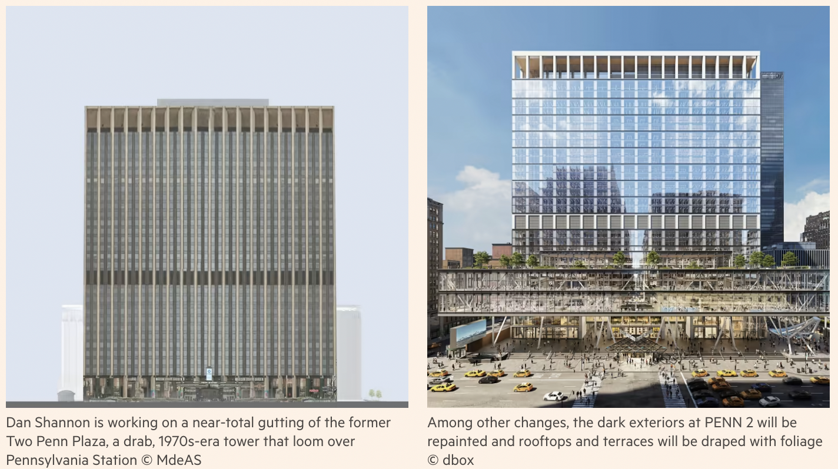

At Penn Plaza, Vornado chief executive Steven Roth has upped the ante. The redevelopment is intended to cast a halo over a benighted corner of Manhattan and offer some penance for the architectural sin of demolishing the original Penn Station in 1963.

“He said, ‘Dan, I don’t want a renovated building. I want a new building,’” said Shannon, who is working on the project with Brad Zizmor of architecture firm A+I.

The towers have been rechristened PENN 1 and PENN 2. The swanky new three-storey lobby at the former is an indication they will bear only a passing resemblance to their former selves when completed. Among other changes, dark exteriors will be repainted and rooftops and terraces will be draped with foliage.

The aim is to take the brooding 1970s design and brighten it for a new era. To improve energy efficiency, new windows will use triple-glazed glass and air conditioning systems will be dispersed throughout the buildings, allowing for cleaner air and more customised cooling.

The Black Rock job will be less extensive, in part because the Eero Saarinen-designed tower was ahead of its time in offering the tall ceilings and natural light prized by today’s office tenants. Still, Shannon and Tom Vecchione of architecture firm Vocon hope to illuminate a recessed lobby that he describes as “a dark pit”. They will also tear up the interior office layouts and install new mechanical systems.

“The flight to quality in New York is clearly happening,” said Jim Vallos, the Harbor Group managing director who hired Shannon to reinvigorate Black Rock. “We’re really looking to restore and enhance it, not just paint it.”

